

FACULTY OF INFORMATION MANAGEMENT

UNIVERSITI TEKNOLOGI MARA

MERBOK, KEDAH

DIPLOMA IN LIBRARY INFORMATICS

(KIM144)

PROGRAMMING FOR LIBRARIES

(IML 208)

INDIVIDUAL ASSIGNMENT : GYM MEMBERSHIP REGISTRATION

BY :

IMAN AMILA REDZA BIN NABIL KHAIRI

( 2022411538 )

GROUP KIM1443D

PREPARED FOR :

SIR MOHD FIRDAUS BIN MOHD HELMI

SUBMISSION DATE :

8 JUNE 2023

**GYM MEMBERSHIP REGISTRATION**

**FILE NAME :** gym_registration.py

**PROMPT DATA :**

* Name
* Birthdate
* Phone number
* Email
* Membership type

**FUNCTION :**

* Create a membership
* Calculate age

**CONDITIONAL STATEMENT :**

* If
* Else
* Try
* Except
* Return

**GUI :**

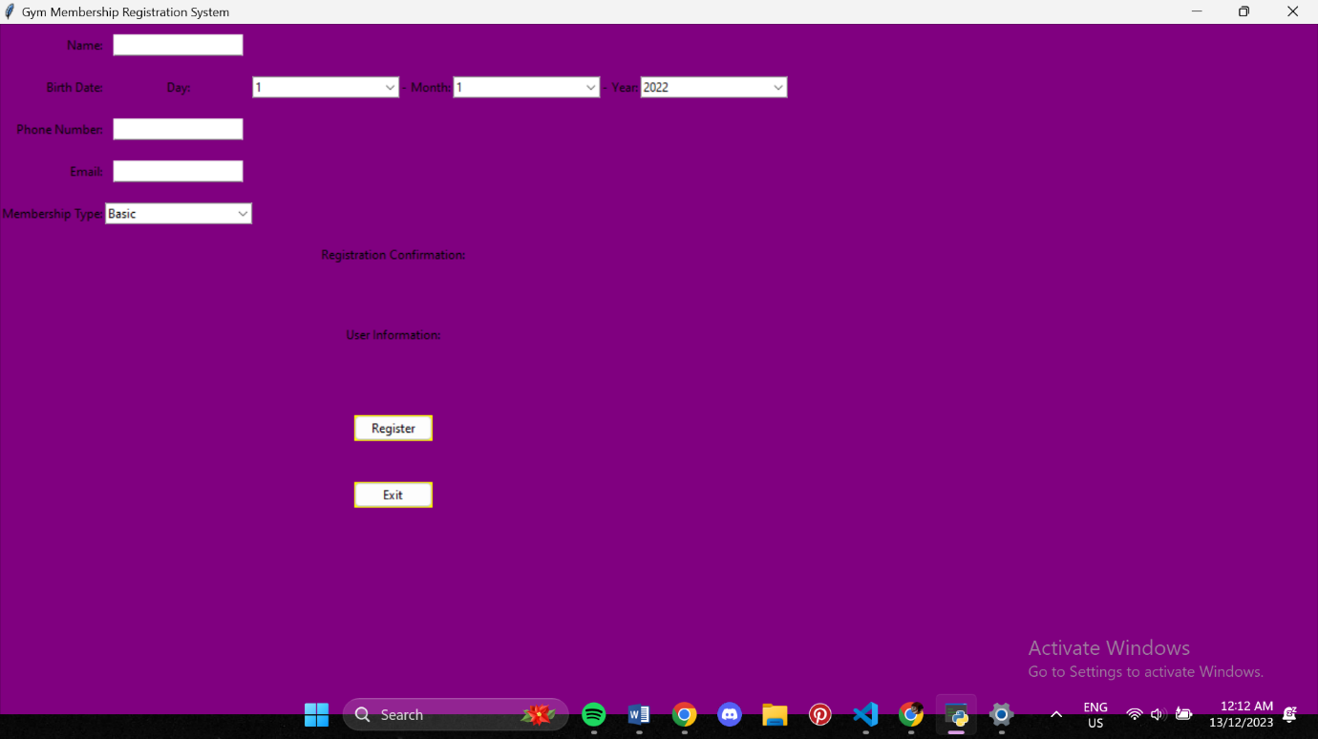

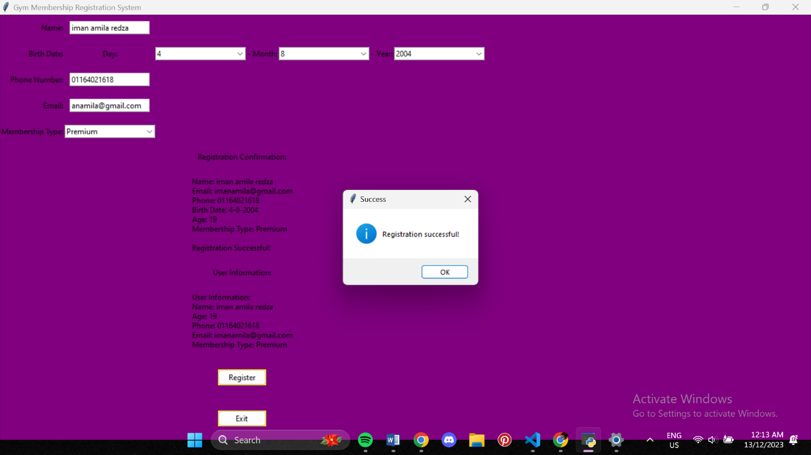

**STRENGTH :**

* Easy to use
* Everything is straight forward
* Helps to fill in birthdate
* Interface is well organised

**KAIZEN (ROOM FOR IMPROVEMENT) :**

* A better interface
* An easier way to fill in email
* An easier way to fill in phone number
* A better diagram showing a membership have been registered